Track Attack Fundraiser 2023
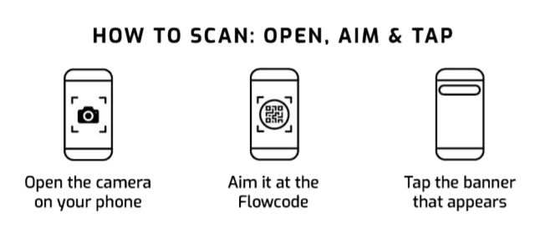
Scan with your phone

Click on “Create Your Campaign” to get started.
CREATE YOUR CAMPAIGN

Step 1. Basic Info - Change Name – [add your name] Panther Track Attack
Change Campaign URL – https://pledgeit.org/yourname Click NEXT
Step 2. Story – You don’t need to change anything in this section. Click NEXT
Step 3. Events – You don’t need to change anything in this section. Click NEXT
Step 4. Funds – You don’t need to change anything in this section. Click NEXT
Step 5. Customization – Add a picture of YOU.

PREVIEW then LAUNCH
Share Your Link with Family & Friends – Ask For Support!
Fundraiser Homepage - https://pledgeit.org/for/panthers2023

